File: Employee_data.csv
EmployeeID,Name,Department,Age,Salary,JoiningDate,Gender
101,Alice,HR,25,50000,01-05-2020,F
102,Bob,IT,30,60000,15-07-2019,M
103,Charlie,HR,35,70000,10-09-2018,M
104,David,Finance,45,80000,20-01-2017,M
105,Eva,IT,28,62000,12-03-2021,F
106,Frank,Finance,50,,30-11-2016,M
107,Grace,HR,26,52000,01-02-2022,F
108,Henry,IT,,58000,18-04-2023,M
109,Irene,Finance,29,75000,01-12-2019,F
110,Jack,HR,31,67000,25-08-2020,M
CODE:
# Loading and Exploring the CSV Data
import pandas as pd
df = pd.read_csv('employee_data.csv') # Load CSV File
print(df.head())
# Inspect DataFrame Info
print(df.info())
print(df.describe(include='all'))
OUTPUT:
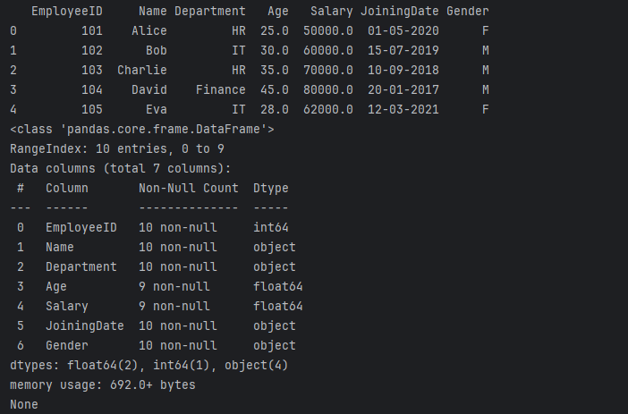
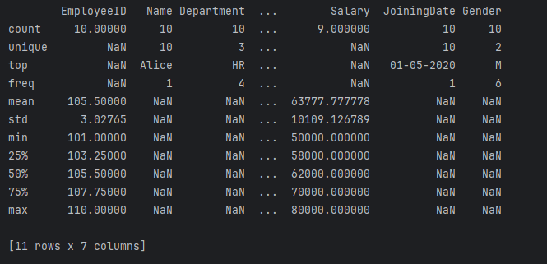

CODE:
# Data Cleaning and Preparation
import pandas as pd
# Load the dataframe
df = pd.read_csv('Employee_data.csv')
print(df.isnull().sum())

# Using pd.to_numeric() with errors='coerce' to handle potential
# non-numeric values and convert them to NaN.
df['Age'] = pd.to_numeric(df['Age'], errors='coerce')
df['Salary'] = pd.to_numeric(df['Salary'], errors='coerce')

# Fill missing 'Age' values with the mean and convert the column to integer.
# re-assigning the result rather than using inplace=True.
df['Age'] = df['Age'].fillna(df['Age'].mean()).astype(int)
# df['Age'].fillna(df['Age'].mean(), inplace=True)

# Fill missing 'Salary' values with the median.
df['Salary'] = df['Salary'].fillna(df['Salary'].median())
# df['Salary'].fillna(df['Salary'].median(), inplace=True)

# Cleaned DataFrame
print("DataFrame after cleaning:")
print(df)

OUTPUT:
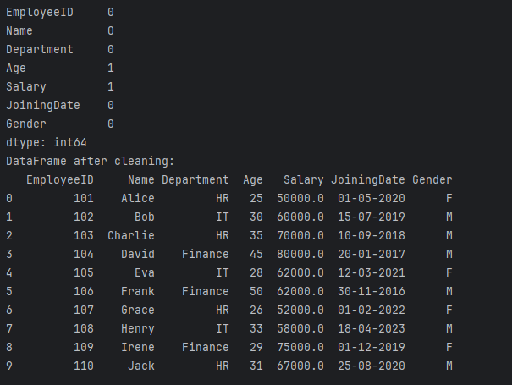

CODE:
# Data Filtering and Selection
# Filter by Department
import pandas as pd
df = pd.read_csv('Employee_data.csv')
it_employees = df[df['Department'] == 'IT']
print(it_employees)
# Employees with Salary > 65000
high_salary = df[df['Salary'] > 65000]
print('\n', high_salary[['Name', 'Salary']])
# Select Specific Columns
print('\n', df[['Name', 'Department', 'Salary']])

OUTPUT:
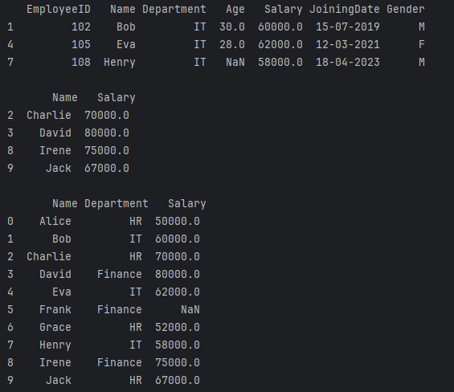

CODE:
# Grouping and Aggregation
import pandas as pd
df = pd.read_csv('Employee_data.csv')
# Average Salary by Department
print('\n', df.groupby('Department')['Salary'].mean())
# Count of Employees by Gender
print('\n', df['Gender'].value_counts())
OUTPUT:
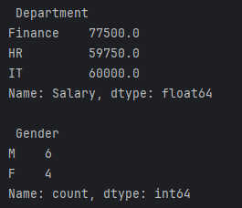

CODE:
# Date Handling and Sorting
import pandas as pd
df = pd.read_csv('Employee_data.csv')
# Convert JoiningDate to datetime
df['JoiningDate'] = pd.to_datetime(df['JoiningDate'], dayfirst=True)
print(df.dtypes)
# Sort by Joining Date
sorted_df = df.sort_values(by='JoiningDate')
print('\n', sorted_df[['Name', 'JoiningDate']])
# Employees Joined After 2020
recent = df[df['JoiningDate'] > '2020-01-01']
print('\n', recent[['Name', 'JoiningDate']])

OUTPUT:
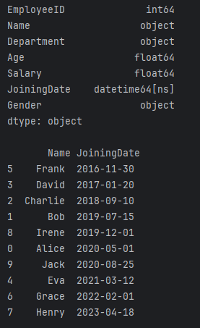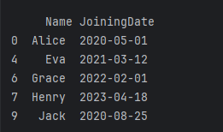
CODE:
# Derived Columns and Exporting
import pandas as pd
from datetime import datetime
df = pd.read_csv('Employee_data.csv')
# Convert JoiningDate properly
df['JoiningDate'] = pd.to_datetime(df['JoiningDate'], dayfirst=True)
# Add Tenure Column (Years)
today = pd.to_datetime(datetime.today())
df['TenureYears'] = (today - df['JoiningDate']).dt.days // 365
print(df[['Name', 'TenureYears']])
# Export Cleaned Data
df.to_csv('employee_data_cleaned.csv', index=False)
OUTPUT:
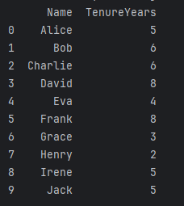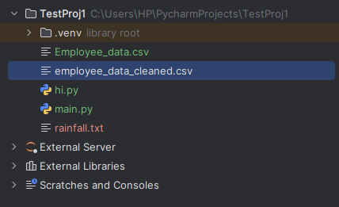
File: employee_data_cleaned.csv
EmployeeID,Name,Department,Age,Salary,JoiningDate,Gender,TenureYears
101,Alice,HR,25.0,50000.0,2020-05-01,F,5
102,Bob,IT,30.0,60000.0,2019-07-15,M,6
103,Charlie,HR,35.0,70000.0,2018-09-10,M,6
104,David,Finance,45.0,80000.0,2017-01-20,M,8
105,Eva,IT,28.0,62000.0,2021-03-12,F,4
106,Frank,Finance,50.0,,2016-11-30,M,8
107,Grace,HR,26.0,52000.0,2022-02-01,F,3
108,Henry,IT,,58000.0,2023-04-18,M,2
109,Irene,Finance,29.0,75000.0,2019-12-01,F,5
110,Jack,HR,31.0,67000.0,2020-08-25,M,5

